WHU-Hi: UAV-borne hyperspectral and high spatial resolution (H2) benchmark datasets for crop precise classification

Yanfei Zhong, Xin Hu, Chang Luo, Xinyu Wang, Ji Zhao, Liangpei Zhang

**Abstract**：WHU-Hi dataset (Wuhan UAV-borne hyperspectral image) is collected and shared by the Intelligent Data Extraction, Analysis and Applications of Remote Sensing(RSIDEA) research group of Wuhan University, and it could serve as a benchmark dataset for precise crop classification and hyperspectral image classification studies. **The WHU-Hi dataset contains three individual UAV-borne hyperspectral datasets: WHU-Hi-LongKou, WHU-Hi-HanChuan, and WHU-Hi-HongHu.** All the datasets were acquired in farming areas with various crop types in Hubei province, China, via a Headwall Nano-Hyperspec sensor mounted on a UAV platform. Compared with spaceborne and airborne hyperspectral platforms, unmanned aerial vehicle (UAV)-borne hyperspectral systems can acquire hyperspectral imagery with a high spatial resolution (which we refer to here as H2 imagery).

1. **WHU-Hi dataset**

The WHU-Hi dataset **preprocessing included radiometric calibration and geometric correction**, which were undertaken in the HyperSpec software provided by the instrument manufacturer. For the radiometric calibration, the raw digital number values were converted into radiance values by the laboratory calibration parameters of the sensor.

* 1. **WHU-Hi-LongKou dataset**

The WHU-Hi-LongKou dataset was acquired from 13:49 to 14:37 on July 17, 2018, in Longkou Town, Hubei province, China, with an 8-mm focal length Headwall Nano-Hyperspec imaging sensor equipped on a DJI Matrice 600 Pro (DJI M600 Pro) UAV platform. During the data collection, the weather was clear and cloudless, the temperature was about 36°C, and the relative air humidity was about 65%. The study area is a simple agricultural scene, which contains **six crop species**: corn, cotton, sesame, broad-leaf soybean, narrow-leaf soybean, and rice. The UAV flew at an altitude of 500 m, the size of the imagery is **550 × 400 pixels**, there are **270 bands from 400 to 1000** nm, and the spatial resolution of the UAV-borne hyperspectral imagery is about 0.463 m. An overview of this dataset is provided in Fig. 1 and Table. 1

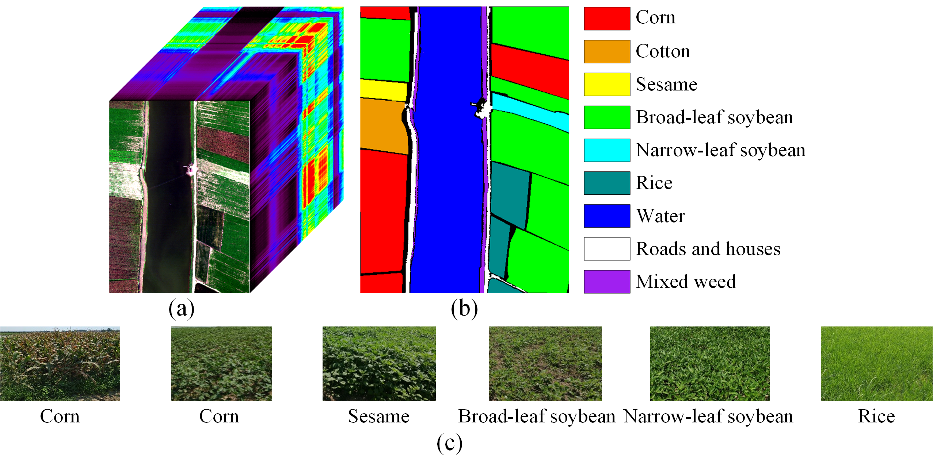

Fig. 1. The WHU-Hi-LongKou dataset. (a) Image cube. (b) Ground-truth image. (c) Typical crop photos in the study area

Table. 1. Groundtruth classes for the WHU-Hi-LongKou dataset and their respective samples number

|  |  |  |
| --- | --- | --- |
| **No.** | **Class name** | **Samples** |
| C1 | Corn | 34511 |
| C2 | Cotton | 8374 |
| C3 | Sesame | 3031 |
| C4 | Broad-leaf soybean | 63212 |
| C5 | Narrow-leaf soybean | 4151 |
| C6 | Rice | 11854 |
| C7 | Water | 67056 |
| C8 | Roads and houses | 7124 |
| C9 | Mixed weed | 5229 |

* 1. **WHU-Hi-HanChuan dataset**

The WHU-Hi-HanChuan dataset was acquired from 17:57 to 18:46 on June 17, 2016, in Hanchuan, Hubei province, China, with an 17-mm focal length Headwall Nano-Hyperspec imaging sensor equipped on a Leica Aibot X6 UAV V1 platform. During the data collection, the weather was clear and cloudless, the temperature was about 30°C, and the relative air humidity was about 70%. The study area is a rural-urban fringe zone with buildings, water, and cultivated land, which contains **seven crop species**: strawberry, cowpea, soybean, sorghum, water spinach, watermelon, and greens. The UAV flew at an altitude of 250 m, the size of the imagery is **1217 × 303 pixels**, there are **274 bands from 400 to 1000 nm**, and the spatial resolution of the UAV-borne hyperspectral imagery is about 0.109 m. Notably, since the WHU-Hi-HanChuan dataset was acquired during the afternoon when the solar elevation angle was low, there are many shadow-covered areas in the image. An overview of this dataset is given in Fig. 2 and Table. 2.

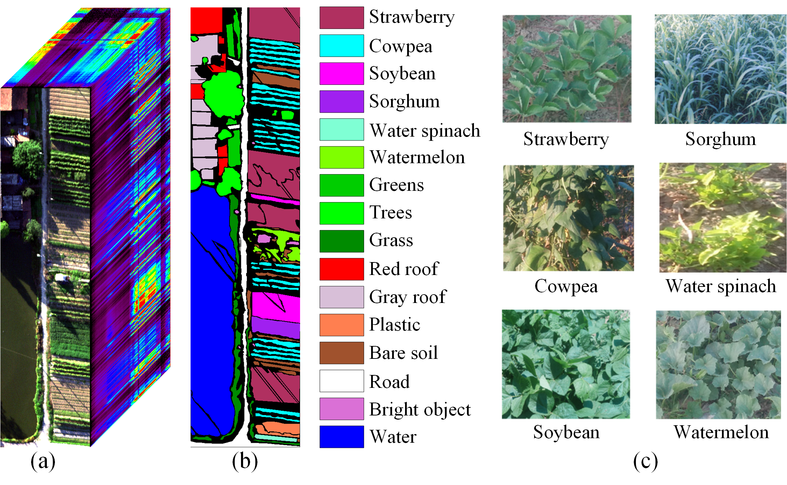

Fig. 2. The WHU-Hi-HanChuan dataset. (a) Image cube. (b) Ground-truth image. (c) Typical crop photos in the study area

Table. 2. Groundtruth classes for the WHU-Hi-HanChuan dataset and their respective samples number

|  |  |  |
| --- | --- | --- |
| **No.** | **Class name** | **Samples** |
| C1 | Strawberry | 44735 |
| C2 | Cowpea | 22753 |
| C3 | Soybean | 10287 |
| C4 | Sorghum | 5353 |
| C5 | Water spinach | 1200 |
| C6 | Watermelon | 4533 |
| C7 | Greens | 5903 |
| C8 | Trees | 17978 |
| C9 | Grass | 9469 |
| C10 | Red roof | 10516 |
| C11 | Gray roof | 16911 |
| C12 | Plastic | 3679 |
| C13 | Bare soil | 9116 |
| C14 | Road | 18560 |
| C15 | Bright object | 1136 |
| C16 | Water | 75401 |

* 1. **WHU-Hi-HongHu dataset**

The WHU-Hi-HongHu dataset was acquired from 16:23 to 17:37 on November 20, 2017, in Honghu City, Hubei province, China, with a 17-mm focal length Headwall Nano-Hyperspec imaging sensor equipped on a DJI Matrice 600 Pro UAV platform. During the data collection, the weather was cloudy, the temperature was about 8°C, and the relative air humidity was about 55%. The experimental area is a complex agricultural scene with many classes of crops, and different cultivars of the same crop are also planted in the region, including Chinese cabbage and cabbage, and Brassica chinensis and small Brassica chinensis. Notably, the region is planted with different cultivars of the same crop type; for example, Chinese cabbage/cabbage and brassica chinensis/small brassica chinensis. The UAV flew at an altitude of 100 m, the size of the imagery is **940 × 475 pixel**s, there are **270 bands from 400 to 1000 nm**, and the spatial resolution of the UAV-borne hyperspectral imagery is about 0.043 m. An overview of this dataset is provided in Fig. 3 and Table. 3

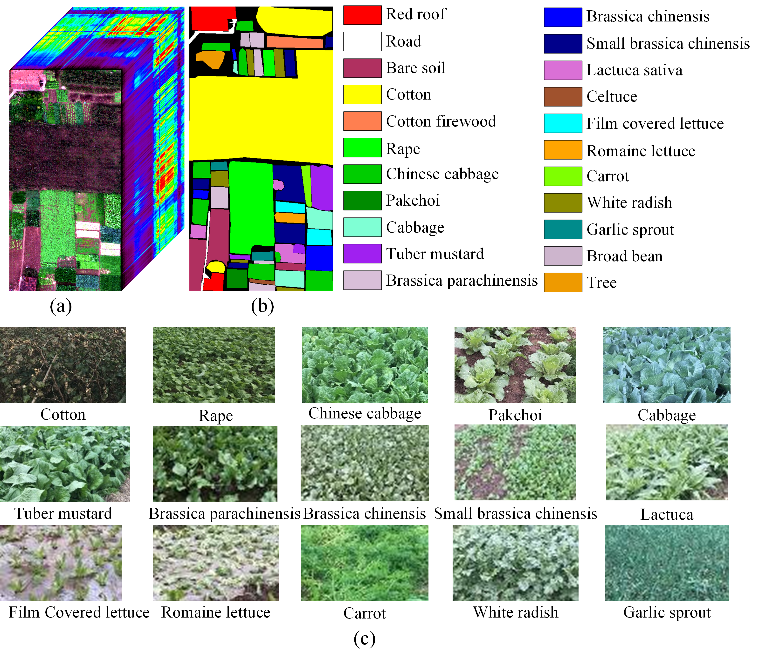

Fig. 3. The WHU-Hi- HongHu dataset. (a) Image cube. (b) Ground-truth image. (c) Typical crop photos in the study area.

Table. 3. Groundtruth classes for the WHU-Hi-HongHu dataset and their respective samples number

|  |  |  |
| --- | --- | --- |
| **No.** | **Class name** | **Samples** |
| C1 | Red roof | 14041 |
| C2 | Road | 3512 |
| C3 | Bare soil | 21821 |
| C4 | Cotton | 163285 |
| C5 | Cotton firewood | 6218 |
| C6 | Rape | 44557 |
| C7 | Chinese cabbage | 24103 |
| C8 | Pakchoi | 4054 |
| C9 | Cabbage | 10819 |
| C10 | Tuber mustard | 12394 |
| C11 | Brassica parachinensis | 11015 |
| C12 | Brassica chinensis | 8954 |
| C13 | Small Brassica chinensis | 22507 |
| C14 | Lactuca sativa | 7356 |
| C15 | Celtuce | 1002 |
| C16 | Film covered lettuce | 7262 |
| C17 | Romaine lettuce | 3010 |
| C18 | Carrot | 3217 |
| C19 | White radish | 8712 |
| C20 | Garlic sprout | 3486 |
| C21 | Broad bean | 1328 |
| C22 | Tree | 4040 |

1. **Copyright**

The copyright belongs to Intelligent Data Extraction, Analysis and Applications of Remote Sensing(RSIDEA) academic research group, State Key Laboratory of Information Engineering in Surveying, Mapping, and Remote Sensing (LIESMARS), Wuhan University. The WHU-Hi dataset can be used for academic purposes only and need to cite the following paper, but any commercial use is prohibited. Otherwise, RSIDEA of Wuhan University reserves the right to pursue legal responsibility.

[1] Y. Zhong, X. Hu, C. Luo, X. Wang, J. Zhao, and L. Zhang, “WHU-Hi: UAV-borne hyperspectral with high spatial resolution (H2) benchmark datasets and classifier for precise crop identification based on deep convolutional neural network with CRF”, *Remote Sens. Environ*., vol. 250, pp. 112012, 2020.

[2] Y. Zhong, X. Wang, Y. Xu, S. Wang, T. Jia, X. Hu, J. Zhao, L. Wei, and L. Zhang, "Mini-UAV-borne hyperspectral remote sensing: From observation and processing to applications", *IEEE Geosci. Remote Sens. Mag*., vol. 6, no. 4, pp. 46-62, Dec. 2018.

1. **Contact**

If you have any the problem or feedback in using WHU-Hi dataset, please contact

Dr. Hu: [whu_huxin@whu.edu.cn](mailto:whu_huxin@whu.edu.cn)

Dr. Wang: [wangxinyu@whu.edu.cn](mailto:wangxinyu@whu.edu.cn)

Prof. Zhong: [zhongyanfei@whu.edu.cn](mailto:zhongyanfei@whu.edu.cn)